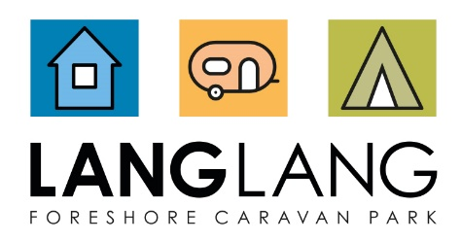
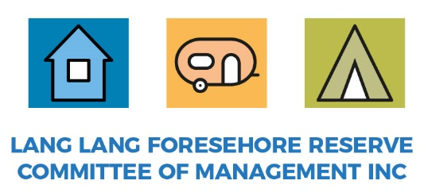

Event Application
Please submit to the Caravan Park Managers: bookings@langlangforeshore.com.au

Event Details | To Complete:
- Date(s) of event
- Event organiser/body
- Organisation/business name
- Organisation/business address
- Organisation/business ABN/ACN if applicable
- Organisation/business email
- Main contact on the day (1):
name, email, phone
- Second contact on the day (2):
name, email, phone
- Further contacts on the day:
name(s), email(s), phone(s)
- Will a qualified First Aider be available?
Y/N and name, email, phone
- Description of event, including activities, fundraising and beneficiaries, noise, etc.
- Proposed location and facilities to be used
- Preparation start time (bump-in)
- Event start time
- Event finish time
- Cleanup finish time (bump-out)
- Estimated # of attendees
- Ticket or entry fees being charged
- List and type of suppliers/third parties on site during event
- Contingency proposal (for rain, etc.)
- Proposed location within Reserve

Please describe the proposed approach to the following:

Proposed Approach | To Complete:
- Marquees, stages, seating, fencing or any other temporary structures
- Use of Park Rotunda
- Toilets
- Power
- Bins/rubbish management
- Filming or photography
- Noise management, use of speakers
- Water
- Food
- Alcohol | Not permitted to be served
- Fireworks | Not permitted to be used

Please describe the status of any consultation or approvals needed (these remain the responsibility of the event organiser):
Consultation & Approvals | To Complete:
- Cardinia Council
- Bass Coast Shire Council
- Police
- SES
- CFA
- Ambulance Victoria
- Other

To attach:
- Certificate of Currency for Public Liability ($20 million minimum)
- Site Map Plan (designating entry/exit points, emergency vehicle access, first aid, evacuation points, car parking, toilets, signage, temporary items including fencing/marquees/amusement rides)
- Risk & Safety Plan (security, first aid)
- Traffic & Parking Management Plan (traffic control, road closures, etc.)

Per the Reserve’s Events Policy, any fees or other services will be discussed and agreed in writing with the event organiser(s) as part of the approval process.

Submitted Date:
Submitted By:
Approved Date:
Approved By:
DEECA notified (Y/N and Date):

